Lab2_a:-

EN | IN | OUT
1 | 0 | 0
1 | 1 | 1
0 | 0 | Hi-Z
0 | 1 | HI-z

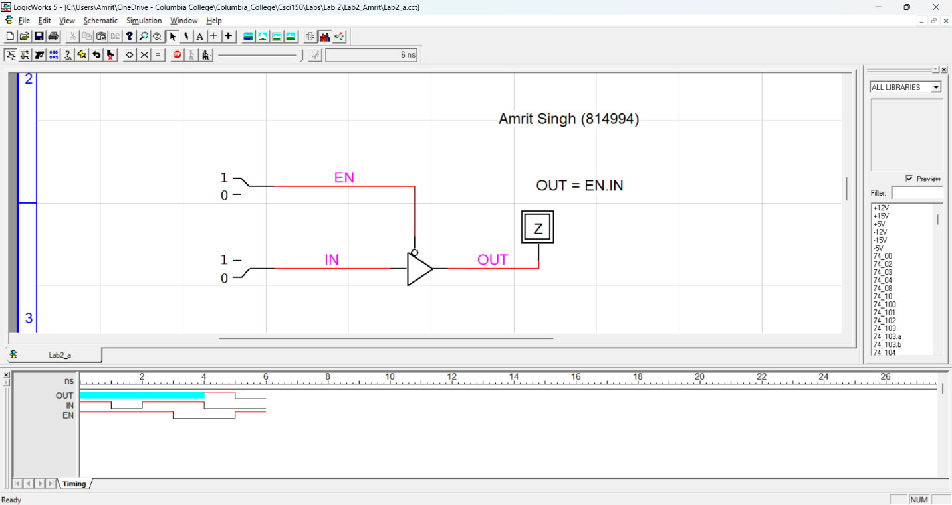

Lab2_b:-

X | Y | Z | H1 | H2 | $$H=\overline{X}Y+XZ$$
0 | 0 | 0 | 0 | Hi-Z | X
0 | 0 | 1 | 0 | Hi-z | X
0 | 1 | 0 | 1 | Hi-Z | 1
0 | 1 | 1 | 1 | Hi-Z | 1
1 | 0 | 0 | Hi-Z | 0 | X
1 | 0 | 1 | Hi-Z | 1 | 1
1 | 1 | 0 | Hi-Z | 0 | X
1 | 1 | 1 | Hi-Z | 1 | 1

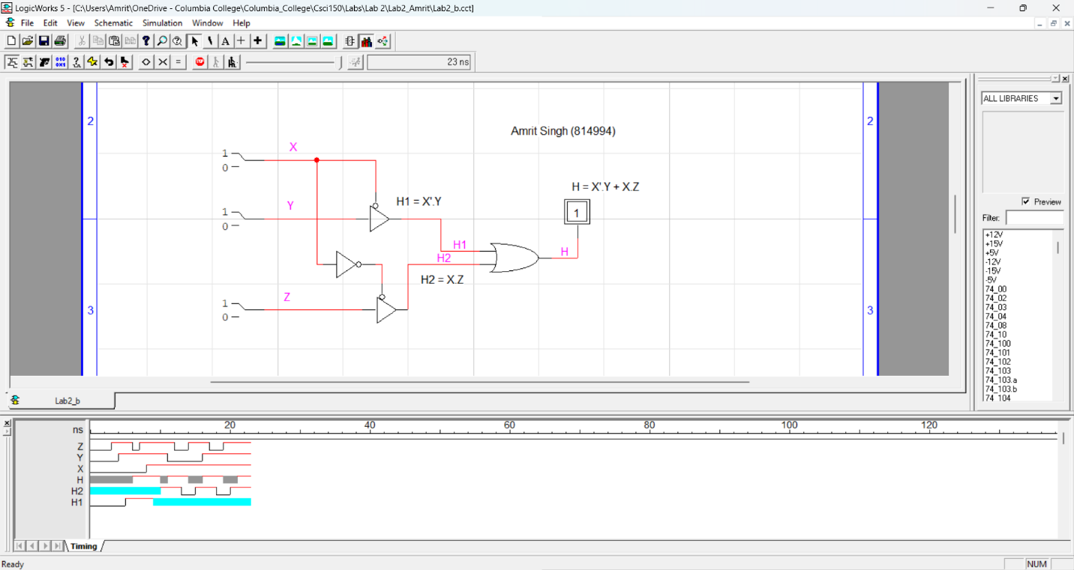

Lab2_b:-

X | Y | $$F=X⊕Y$$
0 | 0 | 0
0 | 1 | 1
1 | 0 | 1
1 | 1 | X (Hi-Z)

